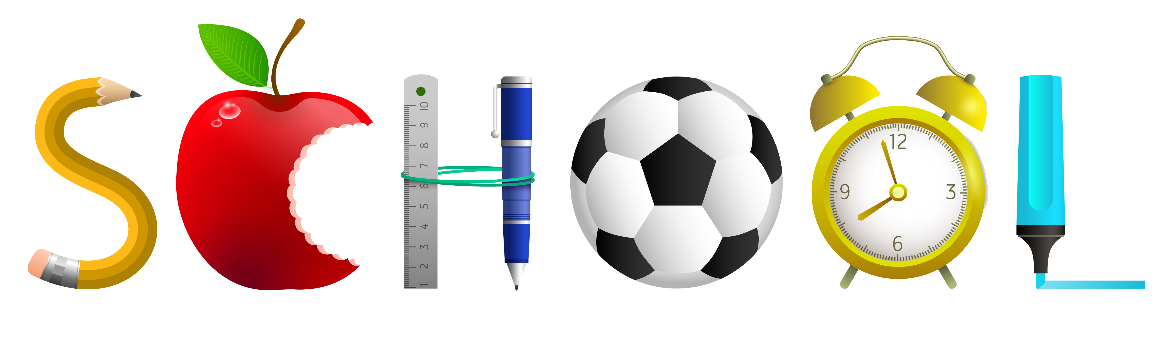Class 3-4 **2024-2025**

* 1 box sharpened pencils, **no mechanical pencils**
* Crayola crayons- 24 pack
* 1 box washable markers
* Colored pencils- 24 pack
* 6 glue sticks
* Safety scissors, **no pointed scissors**
* 6 notebooks- **No spiral notebooks, marble only**
* 6 bottom pocket folders
* Pencil box (8 ½” x 5”)
* 3 packs of index cards
* Headphones-**No Bluetooth headphones**
* 1 thick coloring book or sketchpad, your choice
* 2 packages babywipes
* 2 boxes of tissues
* Hand Sanitizer
* Change of clothing in a bag labeled with your child’s name
* 1 box of Gallon Ziplock bags